How to track Work Based Learning in PowerTeacher Pro
To track a Work Based Learning Activity, attach the KCTC.WBL standard to the applicable assignments and score that standard with an A for Awareness, E for Exploration, P for Preparation, or T for Training.
- Create your assignment as you normally would. To attach the KCTC.WBL standard, click on the Standards tab in the Assignment setup screen.
  - On the Standards tab, uncheck the “Auto-Calculate Assignment Standards Score” box. The reason we do not want to auto-calculate in this case is because the score is not proficiency based, but based on what type of WBL activity they have done.
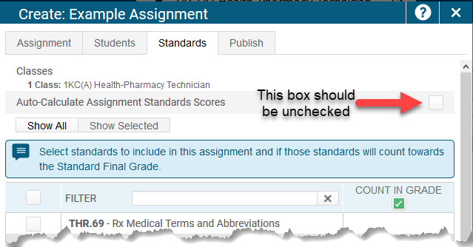
  - Scroll down in the list of standards and place a checkmark next to KCTC.WBL.
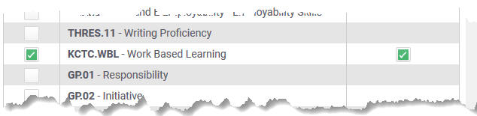
  - Press Save and Close at the bottom of the Window (after all assignment settings have been entered/adjusted).
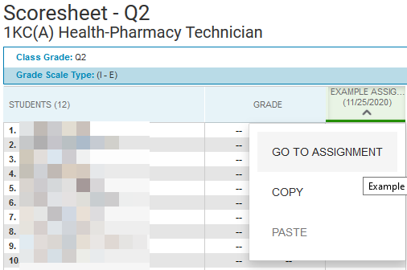
- When scoring the assignment, it is important to be in the view where you can see both the assignment and standard score. On the Scoresheet click the down arrow under the assignment title and choose Go To Assignment.

- If the assignment you are entering is one that counts toward the final grade, then you can enter the assignment score in the Score column. However, an assignment score is not required if you are just entering the assignment to track a WBL activity and the assignment does not count toward the final grade.
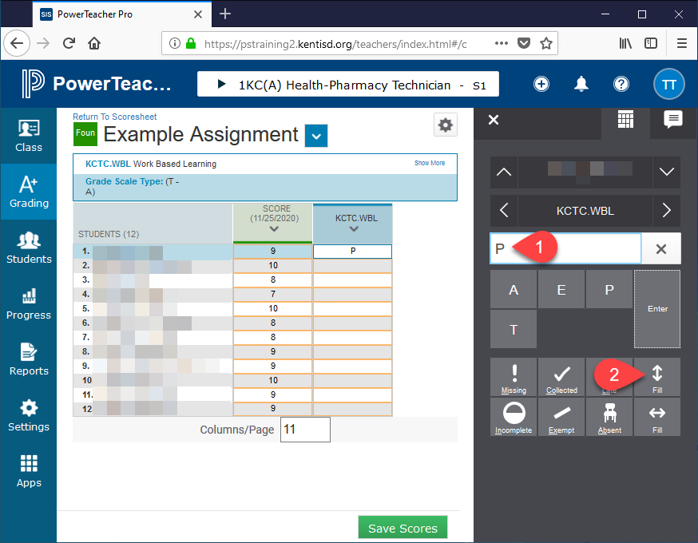
- Enter the letter (A, E, P, or T) for the type of WBL activity into the first student in the KCTC.WBL column. Next, click the down-fill button to fill in that letter for all students.

- You will see the letter you entered fill in for all students and will get a “Fill Complete” Confirmation.
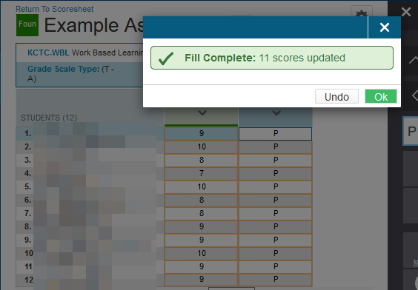
- Click the Save Scores button.

